**BRANDON WONG** - *Required HW Week 1 (02_files_and_weather_lab)*

**PART 1**

Header:

['country', 'beer_servings', 'spirit_servings', 'wine_servings', 'total_litres_of_pure_alcohol', 'continent']

**PART 2**

beers = [0, 89, 25, 245, 217, 102, 193, 21, 261, 279, 21, 122, 42, 0, 143, 142, 295, 263, 34, 23, 167, 76, 173, 245, 31, 231, 25, 88, 37, 144, 57, 147, 240, 17, 15, 130, 79, 159, 1, 76, 0, 149, 230, 93, 192, 361, 0, 32, 224, 15, 52, 193, 162, 6, 52, 92, 18, 224, 20, 77, 263, 127, 347, 8, 52, 346, 31, 133, 199, 53, 9, 28, 93, 1, 69, 234, 233, 9, 5, 0, 9, 313, 63, 85, 82, 77, 6, 124, 58, 21, 0, 31, 62, 281, 20, 82, 19, 0, 343, 236, 26, 8, 13, 0, 5, 149, 0, 0, 98, 238, 62, 0, 77, 31, 12, 47, 5, 376, 49, 5, 251, 203, 78, 3, 42, 188, 169, 22, 0, 306, 285, 44, 213, 163, 71, 343, 194, 1, 140, 109, 297, 247, 43, 194, 171, 120, 105, 0, 56, 0, 9, 283, 157, 25, 60, 196, 270, 56, 0, 225, 284, 16, 8, 128, 90, 152, 185, 5, 2, 99, 106, 1, 36, 36, 197, 51, 51, 19, 6, 45, 206, 16, 219, 36, 249, 115, 25, 21, 333, 111, 6, 32, 64]

len(beers) = 193

**PART 3**

NA_beers = [102, 122, 143, 263, 240, 149, 93, 52, 193, 52, 199, 53, 1, 69, 82, 238, 78, 285, 194, 171, 120, 197, 249]

len(NA_beers) = 23

EU_beers = [89, 245, 21, 279, 21, 142, 295, 76, 231, 230, 192, 361, 224, 224, 263, 127, 52, 346, 133, 234, 233, 313, 85, 281, 343, 236, 149, 0, 31, 251, 169, 343, 194, 109, 297, 0, 283, 196, 270, 284, 152, 185, 106, 206, 219]

len(EU_beers) = 45

**PART 4**

NA_avg = 145.43

**PART 5**

Wrote output to C:\Users\Brandon\SG_DAT1_Brandon\avg_beer.csv

**PART 6**

DATA FOR HANOI

(datetime.datetime(2016, 1, 22, 20, 0), 12.55, 100)

(datetime.datetime(2016, 1, 22, 23, 0), 11.68, 100)

(datetime.datetime(2016, 1, 23, 2, 0), 10.18, 100)

(datetime.datetime(2016, 1, 23, 5, 0), 8.29, 100)

(datetime.datetime(2016, 1, 23, 8, 0), 6.98, 100)

(datetime.datetime(2016, 1, 23, 11, 0), 8.07, 86)

(datetime.datetime(2016, 1, 23, 14, 0), 8.7, 81)

(datetime.datetime(2016, 1, 23, 17, 0), 8.47, 80)

(datetime.datetime(2016, 1, 23, 20, 0), 6.04, 90)

(datetime.datetime(2016, 1, 23, 23, 0), 5.08, 93)

(datetime.datetime(2016, 1, 24, 2, 0), 4.53, 90)

(datetime.datetime(2016, 1, 24, 5, 0), 3.4, 100)

(datetime.datetime(2016, 1, 24, 8, 0), 2.33, 100)

(datetime.datetime(2016, 1, 24, 11, 0), 3.69, 88)

(datetime.datetime(2016, 1, 24, 14, 0), 5.12, 81)

(datetime.datetime(2016, 1, 24, 17, 0), 5.5, 83)

(datetime.datetime(2016, 1, 24, 20, 0), 4.08, 94)

(datetime.datetime(2016, 1, 24, 23, 0), 3.38, 94)

(datetime.datetime(2016, 1, 25, 2, 0), 2.99, 99)

(datetime.datetime(2016, 1, 25, 5, 0), 2.74, 94)

(datetime.datetime(2016, 1, 25, 8, 0), 2.95, 90)

(datetime.datetime(2016, 1, 25, 11, 0), 6.18, 79)

(datetime.datetime(2016, 1, 25, 14, 0), 8.58, 74)

(datetime.datetime(2016, 1, 25, 17, 0), 9.47, 70)

(datetime.datetime(2016, 1, 25, 20, 0), 5.42, 83)

(datetime.datetime(2016, 1, 25, 23, 0), 4.32, 89)

(datetime.datetime(2016, 1, 26, 2, 0), 2.52, 95)

(datetime.datetime(2016, 1, 26, 5, 0), 1.9, 94)

(datetime.datetime(2016, 1, 26, 8, 0), 2.41, 95)

(datetime.datetime(2016, 1, 26, 11, 0), 8.38, 84)

(datetime.datetime(2016, 1, 26, 14, 0), 9.74, 76)

(datetime.datetime(2016, 1, 26, 17, 0), 10.18, 74)

(datetime.datetime(2016, 1, 26, 20, 0), 7.4, 83)

(datetime.datetime(2016, 1, 26, 23, 0), 5.98, 90)

(datetime.datetime(2016, 1, 27, 2, 0), 5.68, 97)

(datetime.datetime(2016, 1, 27, 5, 0), 5.89, 100)

**PART 7**

'Pressure in Hanoi' graph printed out in word file

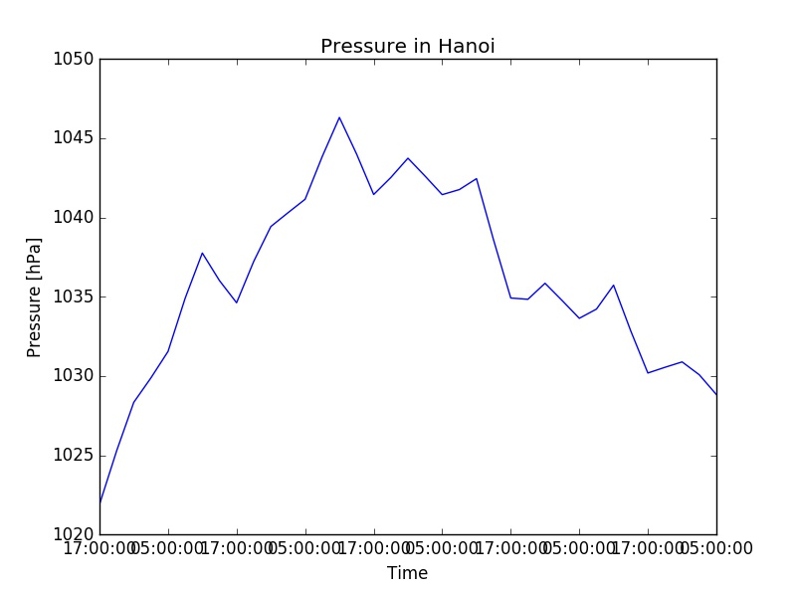

**PART 8**

'Multi-Axis Scatterplot Graph for Hanoi' graph printed out in word file

